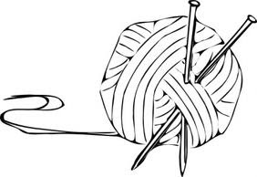
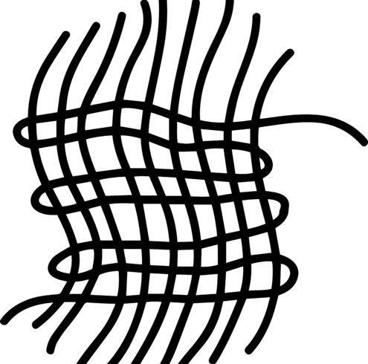
Fiber Arts Camp
at
The ACC!

The Alexandria Community Center & fiber artists Nelly DeVault and Glynnis Kunkel are hosting a Fiber Arts Camp for kids! The classes will introduce spinning yarn by hand, creating textiles via knit, crochet, and weaving, and other fun techniques for making art in this unique medium. There is a limited amount of space, so get your registration and money in as quickly as possible! Details below:

Who: Registration is open to students that are entering grades 5 – 9.

Fee: $70 per student. $50 for siblings. PayPal code can be used to pay as well as cash/check made out to Alexandria Community Center, Inc.

When: July 17-21, 9am-12pm

Where: Alexandria Community Center (315 S. Harrison St., Alexandria, IN 46001)

*Students will have a light snack and drink during camp. Please note allergies below.

** Return this registration form with fee to the ACC during business hours or leave in the drop if outside regular business hours. Please contact Rachel Young at 765-724-7728 or rachelyoungacc@gmail.com with any questions or concerns***

__________________________________________________________________________________________

Student’s name____________________________________ Phone Number____________________________

Parent Email ___________________________________

Age_____ Grade________

Does your child have any health problems or allergies that we should be aware of?

________________________________

Fees must accompany this form unless other arrangements have been made. No refunds will be made. ACC is not responsible for accidents or injuries.

In consideration of participation in the above program(s) conducted by the Alexandria Community Center & Alexandria Community Schools, I do hereby agree to hold free from any liability the ACC and its respective officers, employees, and volunteers. I do hereby for myself, my heirs, executors, and administrators waive, release, and forever discharge and all rights and claims for damages, which may hereafter, accrue to me arising out of or connected with my child’s participation in this program. I attest and verify that the participant listed above is physically fit and I have read this form and understand the expectations of this program.
I give the Alexandria Community Center permission to use pictures taken of my child during sports activities.

Parent/Guardian (please print) _______________________________ Signature_________________________

I would like to contribute $_______ to a scholarship fund that will allow all interested area children to participate in ACC programs.

